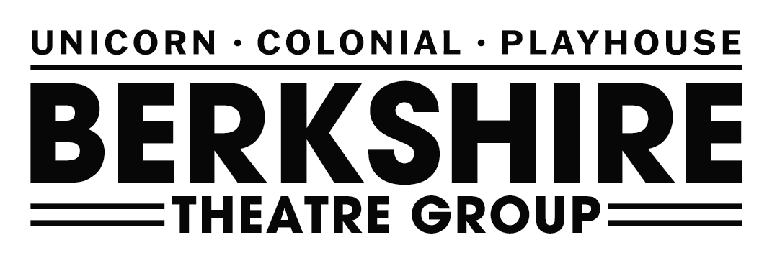

Press Contacts:
Amy Moorby
Communications Manager
(413) 448-8084 x15
amy@berkshiretheatre.org
Becky Brighenti
Director of Marketing & Public Relations
(413) 448-8084 x11
becky@berkshiretheatregroup.org
For Immediate Release, Please:
Berkshire Theatre Group Presents
September Concerts at the Colonial

National Performing Acts

Motor City Fever: A Musical Celebration of Motown
Take a trip back in time to when the great songs of Motown ruled the charts
with Motor City Fever.

Concerts at The Colonial
Don Jovi: A One of a Kind Bon Jovi Concert Performance
Bon Jovi's music comes alive with complete authenticity
and the most legendary and memorable music of all time.

Harvest & Rust: A Neil Young Experience
Beloved Western Massachusetts-based Musicians
cover everything Neil Young and More.

Pittsfield, MA – Berkshire Theatre Group (BTG) and Kate Maguire (Artistic Director, CEO) are excited to present three exciting Concerts at the Colonial, including a national performing act, as well as two regional bands.

Season Discounts & Ticket Information
BTGY (Young Adult)
Young adults between the ages of 18 and 30 can purchase one ticket to any BTG produced show for $30 (fees included). This offer is available by phone or in person only. Additionally, one BTG presented show ticket may be purchased for 10% off the single ticket price (rental events not included).

EBT Card to Culture Program
EBT Card to Culture is a collaboration between the Mass Cultural Council and the Executive Office of Health and Human Services’ Department of Transitional Assistance. This is available to anyone with EBT, WIC, or ConnectorCare Insurance. This offer includes two tickets to the majority of BTG’s shows at the rate of $5 each. All additional fees are also waived. These tickets are subject to availability as seating is limited. This offer is available by phone or in person only.

Massachusetts Teachers Association
Massachusetts Teachers Association (MTA) members are eligible for a discount of 20% off orders to any BTG show. Education is a core value of BTG, and we appreciate those who are doing the work in our community. To redeem this discount, mention it while ordering over the phone at 413-997-4444, or in person at our box office.
AAA
AAA members are eligible for 10% off on orders to any BTG show. To redeem this discount, mention it while ordering over the phone at 413-997-4444, or in person at our box office.
Tickets for these exciting productions are on sale now. All plays, schedules, casting and prices are subject to change. To purchase tickets, visit www.BerkshireTheatreGroup.org or contact our box office by calling 413-997-4444.
The box office is open Tuesday through Sunday 12pm-5pm or on any performance day from 12pm until curtain. BTG’s Pittsfield Campus is located at 111 South Street, (The Colonial Theatre) Pittsfield, MA.

National Touring Acts
at The Colonial Theatre in Pittsfield
Motor City Fever: A Musical Celebration of Motown
at The Colonial Theatre
Saturday, September 16 at 7:30pm
Tickets: $30

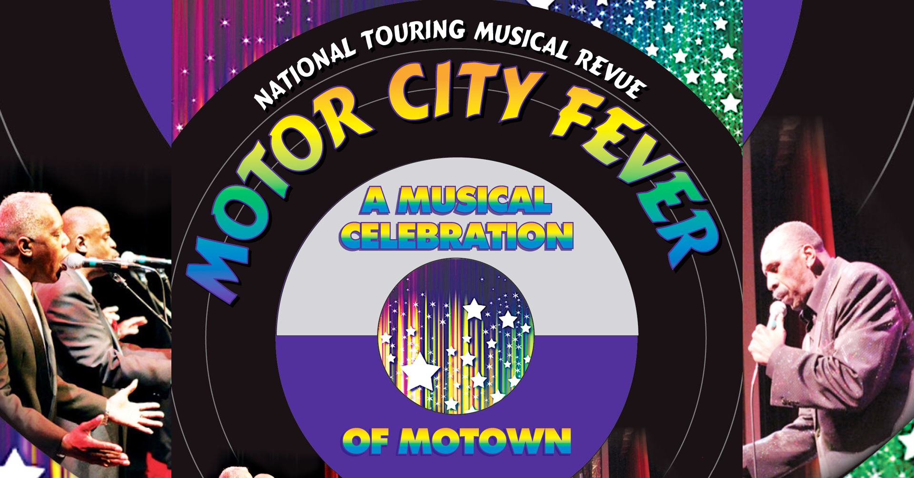

Motor City Fever is an amazing concert experience featuring dozens of legendary Motown hits performed by an incredibly talented cast of performers who have shared the stage with many of the legends themselves. The show includes million-selling hits made famous by artists such as The Temptations, Smokey Robinson, The Supremes, Marvin Gaye, The Four Tops and more! Smooth vocals, tight harmonies and some great choreography straight from Detroit make this an incredibly entertaining show!

Take a trip back in time to when the great songs of Motown ruled the charts with Motor City Fever.

Concerts at The Colonial
At The Colonial Theatre in Pittsfield

Don Jovi

A One of a Kind Bon Jovi Concert Performance

at The Colonial Theatre

Friday, September 22 at 7:30pm

Tickets: $30

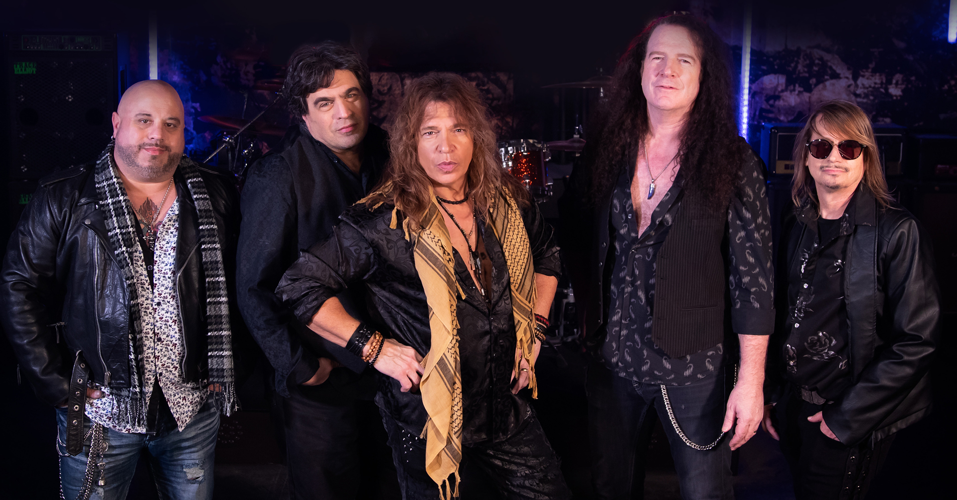

Don Jovi is an exciting one of a kind Bon Jovi concert performance. A fantastic recreation of one of the most popular rock bands to date. Lead singer Don Chaffin gives a remarkable resemblance to Jon Bon Jovi as well as capturing the signature sound of his vocal style. Each member brings their own unique sound and style to the band, giving audiences a complete high energy performance. The magic of Bon Jovi's music comes alive with complete authenticity through the band's commitment to performing some of the most legendary and memorable music of all time.

Harvest & Rust: A Neil Young Experience
at The Colonial Theatre
Friday, September 29 at 7:30pm
Tickets: $30

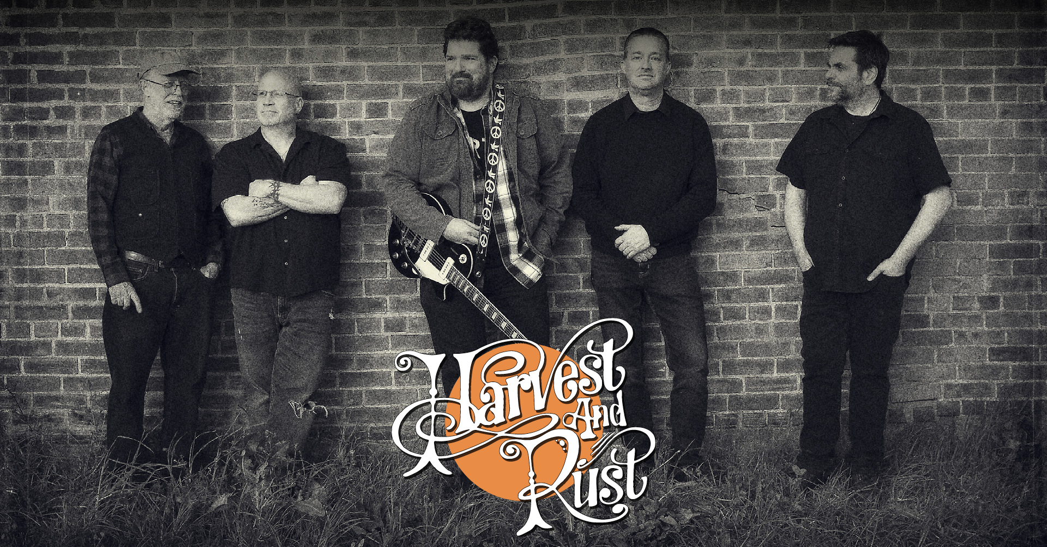

Representing the wide-array of Neil Young’s influential material in one show, Western Massachusetts-based band Harvest & Rust covers everything Neil Young, from the chart-topping Harvest material including "Old Man," and "Heart of Gold," to the more electric explorations of Rust Never Sleeps like "Hey Hey, My My." They also perform songs from Young's time in Crosby, Stills, Nash & Young and Buffalo Springfield.
Harvest & Rust is comprised of a smattering of beloved Western Massachusetts-based musicians: Matt Cahill (from Static), Andy Gordon (from Spurs USA), John Kiernan (from Who Are You: A Tribute to The Who and License to Groove), Garrett Lechowski (from Who Are You: A Tribute to The Who, License to Groove, and American Zeppelin) and Jim Reynolds (from Wild Card and Wishful Thinking).

Full Event Calendar of 2023 Fall & Holiday Shows (in Calendar Order)
Hershey Felder’s Beethoven: A Play with Music at The Colonial Theatre ● Friday, September 8 at 7pm; Saturday, September 9 at 2pm & 7pm; Sunday, September 10 at 2pm ● Tickets: $50

Hershey Felder’s Beethoven: Moonlight Sonata Gala ● Backstage at The Colonial Theatre ● Sunday, September 10 at 2pm ● Tickets (limited): $500/$185

Motor City Fever: A Musical Celebration at The Colonial Theatre ● Saturday, September 16 at 7:30pm ● Tickets: $30

Don Jovi: A One of a Kind Bon Jovi Concert Performance at The Colonial Theatre ● Friday, September 22 at 7:30pm ● Tickets: $30

Copenhagen at The Unicorn Theatre ● Thursday, September 28 through Sunday, October 29 ● Tickets: Preview: $45 & $52

Harvest & Rust: A Neil Young Experience at The Colonial Theatre ● Friday, September 29 at 7:30pm ● Tickets: $30

Diego Mongue Band at On-Stage at The Colonial Theatre ● Thursday, October 12 at 7:30pm ● Tickets: $35 General Admission

The Olivia Show: A Tribute to Olivia Newton-John at The Colonial Theatre ● Sunday, October 15 at 2pm ● Tickets: $30

Dancing Dream: The Music of ABBA at The Colonial Theatre ● Friday, October 20 at 7:30pm ● Tickets: $30

Felipe Salles’ The New Immigrant Experience Concert: A Fundraiser for Berkshire Immigrant Center, The West Stockbridge Historical Society and Berkshire Theatre Group at The Colonial Theatre ● Saturday, October 21 at 7:30pm ● Tickets: $75

Sam Bush: Multi Grammy Award Winner & Father of Newgrass at The Colonial Theatre ● Wednesday, October 25 at 7:30pm ● Tickets: $39

The Rocky Horror Picture Show at The Colonial Theatre ● Saturday, October 28 at 9pm ● Tickets: $25

Black Opry Revue at The Colonial Theatre ● Saturday, November 4 at 7:30pm ● Tickets: $30

Warren Miller’s All Time at The Colonial Theatre ● Thursday, November 16 at 7pm ● Tickets: $20

Guinevere: A Female Tribute to Crosby, Stills & Nash at The Colonial Theatre ● Friday, November 17 at 7:30pm ● Tickets: $30

A Christmas Carol at The Unicorn Theatre ● Thursday, December 7 through Saturday, December 23 ● Tickets: Adult: $56, Child (16 and under): $30

Mutts Gone Nuts: Santa Paws at The Colonial Theatre ● Sunday, December 10 at 2pm ● Tickets: Adult: $30, Child (16 and Under): $15

Second Annual Come Home for The Holidays: A Colonial Family Concert Featuring Members of The Berkshire Music Community hosted by The BTG Youth Chorus at The Colonial Theatre ● Sunday, December 17 at 2pm ● Tickets: Adult: $30, Child (16 and Under): $15

The Wizards of Winter at The Colonial Theatre ● Friday, December 22 at 7:30pm ● Tickets: Adult: $59

New Year’s Eve with Max Creek at The Colonial Theatre ● Sunday, December 31 at 8pm ● Tickets: Advanced: $34, Day of Show: $39

###

Safety Protocols
For safety protocols, please visit BTG’s COVID-19 information page:
www.berkshiretheatregroup.org/covid-19-information/

About Berkshire Theatre Group
The Colonial Theatre, founded in 1903, and Berkshire Theatre Festival, founded in 1928, are two of the oldest cultural organizations in the Berkshires. In 2010, under the leadership of Artistic Director and CEO Kate Maguire, the two organizations merged to form Berkshire Theatre Group (BTG). Berkshire Theatre Group's mission is to support wide ranging artistic exploration and acclaimed performances in theatre, dance, music and entertainment. Every year, BTG produces and presents performances to over 68,000 attendees and, through our Educational Program, serves over 10,000 school children annually in Berkshire County and beyond. In July 2020, Berkshire Theatre was the first company in the United States to earn approval from Actors’ Equity Association to produce a musical (Godspell) in the wake of the COVID-19 Pandemic.

