Press Contacts:
Amy Moorby
Communications Manager
(413) 448-8084 x15
amy@berkshiretheatre.org
Becky Brighenti
Director of Marketing & Public Relations
(413) 448-8084 x11
becky@berkshiretheatregroup.org
For Immediate Release, Please:
Berkshire Theatre Group Announces
Casting for the Upcoming Production of Copenhagen

At The Unicorn Theatre
Winner of the Tony Award for Best Play
Copenhagen
A gripping exploration of the mysterious wartime meeting
between two Nobel laureates to discuss the atomic bomb.

Pittsfield, MA – Berkshire Theatre Group (BTG) and Kate Maguire (Artistic Director, CEO) are excited to announce casting for its upcoming production of Copenhagen, a gripping exploration of the mysterious wartime meeting between two Nobel laureates to discuss the atomic bomb.

Season Discounts & Ticket Information
BTGY (Young Adult)
Young adults between the ages of 18 and 30 can purchase one ticket to any BTG produced show for $30 (fees included). This offer is available by phone or in person only. Additionally, one BTG presented show ticket may be purchased for 10% off the single ticket price (rental events not included).

EBT Card to Culture Program
EBT Card to Culture is a collaboration between the Mass Cultural Council and the Executive Office of Health and Human Services’ Department of Transitional Assistance. This is available to anyone with EBT, WIC, or ConnectorCare Insurance. This offer includes two tickets to the majority of BTG’s shows at the rate of $5 each. All additional fees are also waived. These tickets are subject to availability as seating is limited. This offer is available by phone or in person only.

Berkshire Resident
Full-time Berkshire residents receive a 25% discount on show tickets to any BTG produced show. Limit two tickets per patron per performance. Exclusions include previews, openings, special events and Saturday evening performances. Tickets must be purchased by phone or in person at our box office. A valid Berkshire County driver’s license is required when picking up tickets.

Massachusetts Teachers Association
Massachusetts Teachers Association (MTA) members are eligible for a discount of 20% off orders to any BTG show. Education is a core value of BTG, and we appreciate those who are doing the work in our community. To redeem this discount, mention it while ordering over the phone at 413-997-4444, or in person at our box office.

AAA
AAA members are eligible for 10% off on orders to any BTG show. To redeem this discount, mention it while ordering over the phone at 413-997-4444, or in person at our box office.
Tickets for all of BTG’s exciting productions are on sale now. All plays, schedules, casting and prices are subject to change. To purchase tickets, visit www.BerkshireTheatreGroup.org or contact the Colonial Box Office by calling 413-997-4444.
The Box Office is open Tuesday through Sunday 12pm-5pm or on any performance day from 12pm until curtain. BTG’s Pittsfield Campus is located at 111 South Street, (The Colonial Theatre) Pittsfield, MA. BTG’s Stockbridge Campus is located at 6 East Street, (The Unicorn Theatre) Stockbridge, MA.

At The Unicorn Theatre
Winner of the Tony Award for Best Play
Copenhagen
by Michael Frayn
directed by Eric Hill

on The Larry Vaber Stage
at The Unicorn Theatre

Previews: Thursday, September 28 at 7pm & Friday, September 29 at 7pm
Opening/Press Night: Saturday, September 30 at 7pm
Closing: Sunday, October 29 at 2pm
Tickets: Preview: $45
Tickets: $52

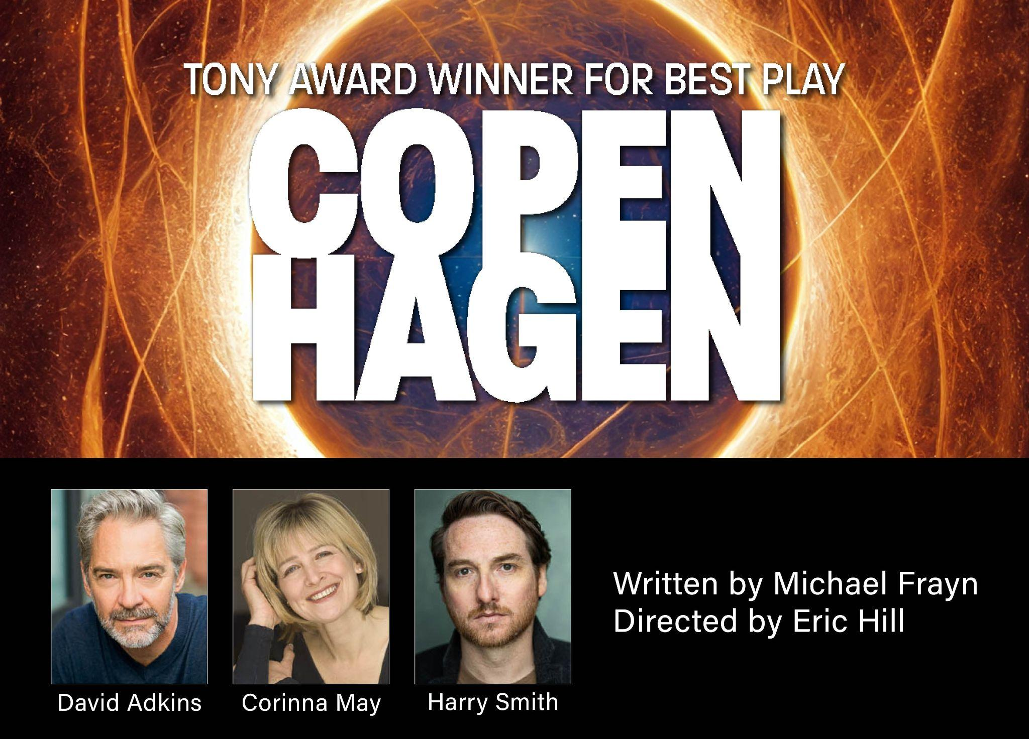

Click here to download headshots
ABOUT
Winner of the Tony Award for Best Play, Copenhagen is a gripping and intellectually stimulating play that explores the events surrounding a mysterious and fateful meeting between two of the most brilliant minds of the 20th century: Niels Bohr and Werner Heisenberg. Niels Bohr is joined by his wife Margrethe, as they engage in a heated and thought-provoking conversation with Heisenberg. As the conversation unfolds, the characters grapple with their past and present roles in the development of atomic weapons and the potential consequences of their work. Set in Nazi-occupied Denmark during World War II, the play is a fascinating exploration of the ethics of science and the consequences of our actions.

Throughout the play, audiences are taken on a thought-provoking journey through the minds of these two Nobel laureate physicists who were at the forefront of the development of the atomic bomb. The play delves deep into their personal lives and the motivations behind their work, exploring the complex relationships between them, their families and their governments.

Copenhagen is a must-see for anyone interested in history, science or politics. It challenges our understanding of the world and forces us to confront the difficult questions that arise when science and politics collide. With its captivating storyline and masterful writing, this play will leave audiences on the edge of their seats and pondering its themes long after the final curtain call.

Suitable for ages 12+

This production will be directed by Eric Hill and feature David Adkins as Niels Bohr, Corinna May as Magarethe Bohr and Harry Smith as Werner Heisenberg.

The creative team of Copenhagen consists of direction by Eric Hill, movement direction by Isadora Wolfe, scenic design by Randall Parsons, costume design by Elivia Bovenzi Blitz, lighting design by Matthew E. Adelson, sound design and composition by Scott Killian, projections design by Adam Lewis, stage management by Caroline Ragland and casting direction by Caparelliotis Casting.

ABOUT THE ARTISTS
David Adkins (Niels Bohr) has performed in numerous productions at Berkshire Theatre Group over the last thirty years. He appeared this season in Photograph 51 by Anna Ziegler and last season in Bram Stoker’s Dracula and in Edward Albee’s Seascape. He has worked On and Off Broadway, in resident theatres across the country, and guest starred extensively on television, most recently for NBC on New Amsterdam. Others include: Madam Secretary, Evil, Homeland, Blacklist, The Good Wife, Elementary, The Americans (two seasons), Happy-ish, Without a Trace, Law and Order, Law and Order SVU, Black Jaq: a pilot directed by Forest Whitaker, and the Ben Franklin mini-series on PBS.

Corinna May (Margarethe Bohr) Berkshire Theatre Group: Edward Albee’s Seascape; Shirley Valentine (2022 “Berkie” Award winner/Solo Performer); The Importance of Being Earnest; Holiday Memories; Benefactors; Same Time, Next Year; Homestead Crossing; Two-Headed. WAM/BTG: The Bakelite Masterpiece. Chester Theatre Company: Circle Mirror Transformation. Great Barrington Public Theatre: Things I Know To Be True (2022 “Berkie” Award winner/Supporting Actress). Shakespeare & Co.(selected): Morning After Grace, Roman Fever, The Unexpected Man, The Memory of Water, A Winter’s Tale, Enchanted April, Jack and Jill, Betrayal, Fortune and Misfortune, House of Mirth, A Midsummer Night’s Dream, Much Ado About Nothing, Hamlet. Wharton Salon: The Long Run, Xingu. Broadway National Tour: The Graduate with Jerry Hall/ Linda Gray/Lorraine Bracco/Kelly McGillis/Morgan Fairchild. Regional(selected): Portland Stage Co., Merrimack Rep., Syracuse Stage, Rep. Theater of St. Louis, Capital Rep. Film: Split Ends (starring); Speck’s Last. TV: House of Cards, Unforgettable, Law & Order. PBS: Evening at the Pops. Playwright: Dancing With the Czar. Intimacy Director: A Wild Party, Othello, Antigone, Making Of A Great Moment. Designated Linklater Voice teacher. Feldenkrais Method practitioner. Theatrical Intimacy Education, 2022 Educator Advocate Program. Faculty: Columbia University School of the Arts; Sands Performing Arts/Actors Studio Drama School/Pace University. Proud union member: AEA, SAG/AFTRA, Dramatists’ Guild.

Harry Smith (Werner Heisenberg) Broadway: King Charles III; Hangmen. Off-Broadway: Robert Icke’s Hamlet and Oresteia (Park Avenue Armory); Plough and the Stars; Juno and the Paycock; Shadow of a Gunman (Irish Rep). Regional: The Tempest (Guthrie); King Charles III (ACT, Seattle Rep, Shakespeare Theatre DC); Dancing at Lughnasa (Two River); The Explorer’s Club (Delaware Theatre Co); Body of an American; The Real Thing; Rapture, Blister, Burn (Wilma Theater); The Mousetrap; An Ideal Husband (Walnut Street Theatre). UK: The Merchant of Venice (Edinburgh Royal Lyceum); Twelfth Night; Les Liaisons Dangereuses (Bristol Old Vic). Television: The Good Wife, Crossbones, Blacklist, Elementary, Jessica Jones, Sprung, The Gilded Age. Film: Freedom; The Goldfinch. Training: Bristol Old Vic; Cambridge University.

ABOUT THE CREATIVE TEAM
Eric Hill (Director) directed Berkshire Theatre Group’s productions of Edward Albee’s Seascape; Shirley Valentine; Holiday Memories; The Goat, or Who is Sylvia?; Naked; At Home at the Zoo (The Zoo Story); The Homecoming; Thoreau or, Return to Walden; Poe; Benefactors; A Christmas Carol; Oklahoma!; A Chorus Line; The Who’s Tommy as well as Snow White and the Seven Dwarfs at the Neil Ellenoff Stage at the Mount. Additional BTG directing credits include: Macbeth, Endgame, Faith Healer, The Einstein Project, Amadeus, The Glass Menagerie, One Flew Over the Cuckoo’s Nest and The Caretaker. Previous acting credits include: Deathtrap, A Man for All Seasons, Dimetos, The Father and Scrooge in A Christmas Carol (2006–2019).

Isadora Wolfe (Movement Director) has worked with choreographers and directors such as Johannes Wieland (NYC and Staatstheater Kassel, Germany), Martha Clarke (Garden of Earthly Delights and Angel Reapers original cast), Mark Dendy, Maxine Doyle and Richard Jones (The Hairy Ape at the Park Avenue Armory). Isadora is now an Associate Artistic Director for Punchdrunk (UK), after her post as Resident Director for its NYC production of Sleep No More. She’s had the pleasure of appearing in several BTG plays (Holiday Memories, Peter Pan, Siddartha, Zorba), and has created movement for productions including The Einstein Project, Holiday Memories, The Importance of Being Earnest, Macbeth, Once, Dracula and Edward Albee’s Seascape. Isadora teaches and coaches dancers and actors at various institutions and festivals, and is adjunct faculty at The Juilliard School.

Randall Parsons (Scenic Designer) Past seasons at BTG: Songs For A New World, dir: Gerry McIntyre; Footloose, dir: Kathy Jo Grover; Godspell, dir: Alan Filderman; What the Jews Believe, dir: Mark Harelik; What We May Be, Coming Back Like a Song!, Arsenic and Old Lace, and White Christmas, dir: Gregg Edelman; Tarzan and Shrek The Musical, dir: Travis Daly; Edward Albee’s Seascape, Shirley Valentine, Holiday Memories, The Goat, Or Who Is Sylvia?, Naked and At Home at the Zoo, dir: Eric Hill; Lost Lake, dir: Daisy Walker; Finnian’s Rainbow, A Thousand Clowns and Same Time, Next Year, dir: Kyle Fabel; The Mystery of Irma Vep and Deathtrap, dir: Aaron Mark. Other recent designs include: Pride and Prejudice, dir: Jason O’Connell, Playhouse on Park; Tinker to Evers to Chance and Home of the Brave, dir: Sean Daniels, Merrimack Repertory Theatre; A Little Night Music, dir: Clayton Phillips, The Barnstormers Theatre; The Bridges of Madison County, Sweeney Todd, Nine, Jekyll and Hyde, A Christmas Carol, Big River and Saturday Night Fever, dir: Jeffrey Sanzel, Theatre Three (as resident designer). Art Direction: Tim Gunn’s Guide to Style (Bravo), The Late Show with David Letterman (CBS) and Mike Birbiglia’s Thank God for Jokes (Netflix). MFA: NYU Tisch. Proud member of United Scenic Artists Local 829, IATSE.

Elivia Bovenzi Blitz (Costume Designer) is a costume designer based in New York City. She has spent the past six seasons in The Berkshires designing costumes for Berkshire Theatre Group and Barrington Stage Company. For BTG: The Smile of Her, Photograph 51, Edward Albee’s Seascape, Once, White Christmas, The Wizard of Oz and Shirley Valentine. For BSC: A Glass Menagerie, Typhoid Mary, The Birds, American Underground, If I Forget, Kunstler, Peerless and Time Flies and Other Comedies, for which she was nominated for a 2019 Berkshire Theatre Critics Award for Outstanding Costume Design. Over the course of her career, she has worked on Broadway, Off Broadway and regionally. She has worked at the Guthrie Theater, The Public Theater, Alliance Theatre, Notre Dame Shakespeare Festival, Two River Theater, Hartford Stage, LaMaMa, Ars Nova, NYU, Yale and Troy Foundry Theater, among others. She holds an MFA in Design from the Yale School of Drama and is an Adjunct Professor of Fashion History at FIT. Member of United Scenic Artists Local 829.

Matthew E. Adelson (Lighting Designer) Previously for BTG: Edward Albee’s Seascape, Once, White Christmas, Shirley Valentine, Nina Simone: Four Women,The Wizard of Oz, Holiday Memories, Godspell, A Christmas Carol (2006 to 2019 and this season), Shrek The Musical, The Goat, or Who is Sylvia?, Naked, Tarzan, The Music Man, Fiorello! (Stockbridge and New York), Thoreau, Poe, Tommy, Babes in Arms, Red Remembers, The Einstein Project, Broadway By The Year, A Man for All Seasons, Caretaker, One Flew Over the Cuckoo’s Nest, The Glass Menagerie, Amadeus, Rat in the Skull, The Misanthrope, Floyd Collins, Talley’s Folly, A Saint She Ain’t (Stockbridge and Westport), Miss Julie, Dream Play, Love’s Fire, Secret Lives of the Sexists and Life’s A Dream. He has also designed extensively throughout the Berkshires, for Great Barrington Public Theater (including The Stones and Just Another Day this season), Barrington Stage, Chester Theatre, Shakespeare & Company, Berkshire Playwrights Lab, Berkshire Opera, Jacob’s Pillow and Williams College, among others. Also this fall: Savage/Love & Tongues (Bardavon at the Woodstock Playhouse). Matthew is the Production Manager for Five College Dance, in the Pioneer Valley (Amherst, Hampshire, Mount Holyoke, Smith colleges and UMass Amherst) and was the Director of Production for the Mahaiwe Performing Arts Center from 2005 to 2014. MFA: Yale Drama School.

Scott Killian (Resident Composer/Sound Designer) Copenhagen marks Scott Killian’s 54th production with the Berkshire Theater Group for which he is enormously grateful. NYC venues include: Primary Stages: Final Follies; Manhattan Theatre Club: Sarah, Sarah; Five by Tenn, A Picasso (Lucille Lortel nom.), The Other Side; The Public Theater: Lenny and the Heartbreakers; Red Bull Theatre: Volpone, Duchess of Malfi, Women Beware Women, Edward the Second; Rattlestick Theatre: Steve and Idi, Miss Julie; MCC: Side Effects; Westside Arts Theatre: Clever Little Lies. Many regional theaters, including: George Street Playhouse (over 25 productions), The Alley Theatre, Shakespeare Theatre (DC), Huntington Theatre, Seattle Repertory Theatre, Cleveland Playhouse, Cincinnati Playhouse, Baltimore’s Center Stage, Vancouver Playhouse, Theatre Calgary, et al. Original music for dance: Zvi Gotheiner (Resident Composer), Shapiro and Smith Dance (Resident Composer), Cherylyn Lavagnino (Artistic Associate), Alvin Ailey American Dance Theatre, Hubbard Street Dance Chicago, Nikolais-Louis Dance, The Jose Limon Company.

Adam Lewis (Projections Designer) is the Audio and Projections Supervisor here at BTG and is thrilled to be a part of this production. Other BTG Design credits include: The Secret Garden: The Spring Version, Footloose, Moana Jr., and Magic Tree House touring shows. Other selected works include: Every Brilliant Thing (RITU Festival, Belgium), Purdue Theatre: Nell Gwynn, Water By The Spoonful, In The Blood. BA Purdue University.

Caroline Ragland (Stage Manager) is thrilled to be joining the Berkshire Theatre Group team this fall for Copenhagen! Previous stage management credits include: Candida (Gingold Theatrical); Goldie, Max & Milk (59e59); Golem Owned a Tropical Smoothie (54 Below); As You Like It (Shakespeare on the Sound);, Housewives of Secaucus, Metamorphosis (Actors Temple Theatre); Rearview Mirror (Theatre Center); Fourscore and Seven Years Ago, My Heart in a Suitcase & Judy Moody and Stink (ArtsPower); Nine, Pippin, Head Over Heels & Ubu Rock (New Studio on Broadway); The Little Mermaid Jr., A Peter Rabbit Tale & Next to Normal (Mill Mountain Theatre); All Hallow's Eve (Connelly Theatre, Dir. Martin P. Robinson); The Notebook (Developmental Workshop) & Short Shakespeare! Macbeth (Chicago Shakespeare). A graduate of CCPA at Roosevelt University, she holds a BFA in Musical Theatre.

David Caparelliotis/Caparelliotis Casting (Casting Director) Current television: New Amsterdam (series casting, NBC). Recent and select Broadway: Who’s Afraid of Virginia Woolf, The Minutes, The Waverly Gallery, The Boys in the Band, King Lear, Hillary and Clinton, Ink, Jitney, The Little Foxes, Three Tall Women, Meteor Shower, A Doll’s House Part 2, The Front Page, The Glass Menagerie, Blackbird, Fish in the Dark, Disgraced, Fences. Other theatre: Manhattan Theatre Club, Signature Theatre NYC season casting, Atlantic Theater Company Stage 2 season casting, Old Globe season casting, Ars Nova, Goodman, Berkeley Rep, McCarter, Arena Stage, Seattle Rep, among others. Additional film and television credits include Boys in the Band (Netflix), American Odyssey (series casting, NBC), How to Get Away with Murder (pilot, ABC), Ironside (NBC), and Steel Magnolias (Sony for Lifetime). David is a proud member of the Casting Society of America, an active member of CSA’s Diversity and Inclusion Committee, and a recent recipient of the Media Access Award for his work on New Amsterdam.

###

Safety Protocols
For safety protocols, please visit BTG’s COVID-19 information page:
www.berkshiretheatregroup.org/covid-19-information/

About Berkshire Theatre Group
The Colonial Theatre, founded in 1903, and Berkshire Theatre Festival, founded in 1928, are two of the oldest cultural organizations in the Berkshires. In 2010, under the leadership of Artistic Director and CEO Kate Maguire, the two organizations merged to form Berkshire Theatre Group (BTG). Berkshire Theatre Group's mission is to support wide ranging artistic exploration and acclaimed performances in theatre, dance, music and entertainment. Every year, BTG produces and presents performances to over 68,000 attendees and, through our Educational Program, serves over 11,000 Berkshire County school children annually. In July
2020, Berkshire Theatre was the first company in the United States to earn approval from
Actors’ Equity Association to produce a musical (Godspell) in the wake of the COVID-19
Pandemic.

