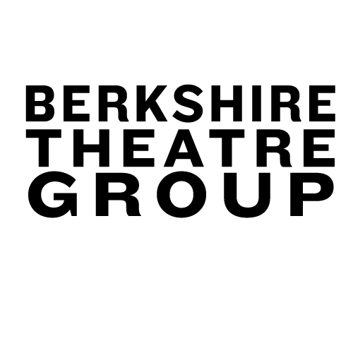

Press Contacts:

Rebecca Brighenti, (413) 448-8084 x11
rbrighenti@thecolonialtheatre.org
www.BerkshireTheatreGroup.org
Colleen Hughes, (413) 448-8084 x15
marketing@thecolonialtheatre.org
www.BerkshireTheatreGroup.org

For Immediate Release, please: Wednesday, April 4, 2012

Berkshire Theatre Group Announces April Programming for The Garage
Pittsfield, MA – Berkshire Theatre Group is proud to announce new programming for The Garage, located in the lobby of The Colonial Theatre in Pittsfield. The April lineup includes a variety of touring acts from around the country, ranging in genre from upbeat, high-energy funk, to grass-roots Americana.

April brings a string of touring and regional acts to The Garage including Brooklyn-based Sister Sparrow and the Dirty Birds, Georgia-based Larkin Poe and The Shadowboxers, Boston-based Session Americana as well as local and regional favorites Sparkplug with special guest Scott Murawski, The Arthur Holmes Blues Band and Tory Hanna. Berkshire Theatre Group’s Youth Advisory Board will also present their first showcase of local high school talent on April 21.
Located in the lobby of The Colonial Theatre, The Garage pays homage in its name to the old Berkshire Auto Co. Garage. The building, originally built in 1921, still features the original façade, while the interior is fully restored, having been included in The Colonial Theatre restoration in 2006. The venue provides a space for local musicians to thrive as well as draws up and coming regional musicians to downtown Pittsfield.
Sparkplug featuring Scott Murawski of Max Creek
Thursday April 5, 2012 at 9pm
$5 Cover
www.sparkplugband.com

Sparkplug brings their driving funk back for their second stint at The Garage, this time featuring the soaring guitar sounds of Scott Murawski, of the legendary band, Max Creek. Sparkplug features organist Beau Sasser and drummer Bill Carbone, who spent several years as the other two thirds of the late, legendary soul-jazz guitarist Melvin Sparks' trio. By performing the songs that Sparks wrote and performed during his 45-year career, Bill and Beau pay tribute to their friend and mentor.

Sister Sparrow &The Dirty Birds
with opener Tory Hanna
Thursday April 12, 2012 at 9pm
$10 ticket in advance, $12 ticket day of show
www.sistersparrow.com

Sister Sparrow &The Dirty Birds are led by Arleigh Kincheloe (Sister Sparrow), whose astoundingly powerful voice and sly demeanor make for a spellbinding presence onstage. She is backed by the mighty force of The Dirty Birds, a flock of eight men who masterfully lay down thundering grooves and soaring melodies. While each of the Birds is capable of lighting up the stage with jaw-dropping displays of musicianship, it is clear that they are focused on delivering the band's infectious music as a single entity. Simply put, the band's live show is explosive. Sister Sparrow &The Dirty Birds' blend of seductive soul and dirty blues-rock reminds audiences why they love live music. Tory Hanna returns to The Garage solo to open the night.
Tickets to Sister Sparrow and the Dirty Birds are on sale now. Tickets may be purchased in person at The Colonial Theatre Ticket Office at 111 South Street Pittsfield, MA 01201 or by calling (413) 997-4444 or online at www.BerkshireTheatreGroup.org. The Ticket Office is open Monday-Friday 10am–5pm, Saturdays 10am–2pm or on any performance day from 10am until intermission.
Session Americana
Wednesday April 18, 2012 at 8pm
$7 Cover
www.sessionamericana.com

The musicians of Boston-based Session Americana sit tightly around a small table with ambient mics tuned to catch the complete sound of the voices and instruments. Players swap songs and instruments: a suitcase drum kit, an old electric bass, a field organ and a collection of acoustic instruments. The unique format feels fantastically theatrical and although the musicians face each other, the audience feels drawn into the circle by the warmth, joy and camaraderie that emanate outwards from the all-star cast of characters seated around the table.

Athur Holmes Blues Band
Thursday April 19, 2012 at 9pm
$5 Cover
www.arthurholmesbluesband.com

The Pittsfield-based Arthur Holmes Blues Band brings their honest brand of Berkshire-infused blues to The Garage for the first time for what is sure to be an electric night of rock solid blues music. The band features Arthur Holmes on guitar and vocals, John Worth, on bass, Gary Smith, on Hammond C-3 organ and Bridget Wynuski, on drums.

BTG Youth Advisory Board Showcase
Saturday April 21, 2012 at 7:30pm
$5 Cover

Berkshire Theatre Group’s own Youth Advisory Board presents a night of music and entertainment featuring local talent from many of the region’s high schools. Musicians featured will include singer/songwriter Katrina Valenti, blues-rock trio The Big Descarte and local rock phenomenon, The Wrong Inspiration.

Larkin Poe with The Shadowboxers
Thursday April 26, 2012 at 9pm
$10 Cover
www.larkinpoe.com • www.theshadowboxers.com

The sisters Rebecca and Megan Lovell who front Larkin Poe have collaborated with Elvis Costello and wowed audiences at festivals such as Bonaroo and Telluride with their radiant, infectious folk-rock. The Shadowboxers, out of Atlanta, GA are in the midst of recording their first full-length album as they gear up for a summer tour with the Indigo Girls.

For audio and video clips as well as more information about the performances, please visit our website at www.BerkshireTheatreGroup.org

###
About Berkshire Theatre Group
The Colonial Theatre, founded in 1903, and Berkshire Theatre Festival, founded in 1928, are two of the oldest cultural organizations in the Berkshires. Having united in November of 2010 under the leadership of Artistic Director and CEO Kate Maguire, these two institutions are providing the Berkshires and beyond with the finest in live theatre, music, dance and the visual arts on three stages in Stockbridge, MA and Pittsfield, MA. The Fitzpatrick Main Stage (408 seats), cataloged by the National Register of Historic Places, was originally designed and built by Stanford White as the Stockbridge Casino in 1888. The intimate Unicorn Theatre (122 seats) is a home for emerging artists and new theatrical ideas. The Colonial in Pittsfield (800 seats) re-opened in August of 2006, following a $21 million restoration, and boasts pristine acoustics, classic gilded age architecture and state-of-the-art technical systems. Together they serve over 100,000 patrons per year and reach over 10,000 students through their educational and outreach programs. For more information on BTF call (413) 298-5536 and on The Colonial call (413) 448-8084. To purchase tickets, call (413) 997-4444 or (413) 298-5576 or go online to BerkshireTheatreGroup.org.

