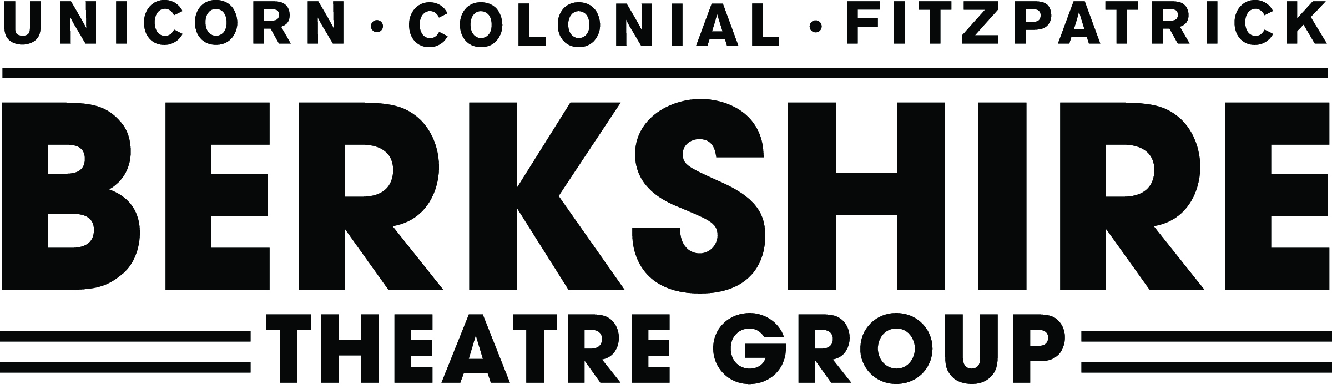

Press Contacts:

Rebecca Brighenti, (413) 448-8084 x11
rbrighenti@thecolonialtheatre.org
www.BerkshireTheatreGroup.org
Colleen Hughes, (413) 448-8084 x15
chughes@thecolonialtheatre.org
www.BerkshireTheatreGroup.org
For Immediate Release, please: Tuesday, May 1, 2012

Dark Star Orchestra Raises the Dead, the Grateful Dead that is, at The Colonial Theatre
Pittsfield, MA – Dark Star Orchestra arrives at The Colonial Theatre on May 22 at 7:30pm, bringing with them song-for-song recreations of Grateful Dead performances. However this isn’t any ordinary tribute band, according to the Washington Post, Dark Star Orchestra is “A cover band for people who don't like cover bands.”
Tickets to Dark Star Orchestra are $25-$35. Tickets may be purchased in person at The Colonial Theatre Ticket Office at 111 South Street Pittsfield, MA 01201 or by calling (413) 997-4444 or online at www.BerkshireTheatreGroup.org. The Ticket Office is open Monday-Friday 10am–5pm, Saturdays 10am–2pm or on any performance day from 10am until intermission.
Dark Star Orchestra’s shows are built off the extensive catalog of the Grateful Dead. On any given night the band will perform a show based on a set list from the Grateful Dead's 30 years of extensive touring or use the catalog of original songs and often played covers to create a unique set list for the show. This allows music fans both young and old to share in the experience. Dark Star Orchestra presents its critically acclaimed live show at esteemed venues from coast to coast and internationally. Grateful Dead classics are performed in the same way that an orchestra interprets music of classical composers. The composer’s spirit is derived and channeled as the players capture the excitement and innovation of the original performances and compositions. Continuing a long and strange trip since humble beginnings over a decade ago, Dark Star Orchestra’s determined commitment to ‘raising the Dead’ has drawn nationwide attention.
Made up of Jeff Mattson (Jerry Garcia), Lisa Mackey (Donna Jean Godchaux), Dino English (Bill
Kreutzmann), Rob Koritz (Mickey Hart), Kevin Rosen (Phil Lesh), Rob Eaton (Bob Weir) and Rob
Barraco (multiple keyboardists), Dark Star Orchestra does not try to match Grateful Dead live songs note for note. Anything so formulaic would quickly dispel the free spirit embodied in the music.
While faithful improvisation is pinnacle, precision is of equal importance with DSO, which position the stage plot based on the year of Grateful Dead show to be performed, adapting phrasing, voice arrangements, and even arranges specific musical equipment for the various eras of Dead music performed. At the end of each performance, the band announces the date and venue where the original show just covered took place. Dark Star Orchestra dips into every incarnation of the Dead, so most fans can “see” shows that happened long before they were born.
"Quite possibly the most talented and accomplished tribute band out there... they've definitely
mastered their inspiration's vagabond nature." – RollingStone.com
"Recreates the Dead concert experience with uncanny verisimilitude... In fact, Dark Star Orchestra
often sounds more like the Dead than the Dead sometimes did." – Chicago Tribune
Critics aren’t the only ones singing Dark Star Orchestra’s praises. Numerous original members of the
Grateful Dead have played alongside DSO and Grateful Dead co-founder Bob Weir has even said, “A couple of times when I had my back to John onstage and he started to sing, I had this weird sense
that it was Jerry.”

Dark Star Orchestra isn’t a cover band. Its shows are not even meant as tributes. What Dark Star
Orchestra tirelessly strives for and achieves is a continuation of the spirit of what has now become over forty years of the Grateful Dead’s timeless music.
To download high-res images, please visit our online gallery at http://gallery.berkshiretheatre.org/main.php?g2_itemId=5737&g2_page=2.
For video clips as well as more information about the performance, please visit our website at www.BerkshireTheatreGroup.org
###
About Berkshire Theatre Group
The Colonial Theatre, founded in 1903, and Berkshire Theatre Festival, founded in 1928, are two of the oldest cultural organizations in the Berkshires. Having united in November of 2010 under the leadership of Artistic Director and CEO Kate Maguire, these two institutions are providing the Berkshires and beyond with the finest in live theatre, music, dance and the visual arts on four stages in Stockbridge, MA, Pittsfield, MA and Lenox, MA. The Fitzpatrick Main Stage (408 seats), cataloged by the National Register of Historic Places, was originally designed and built by Stanford White as the Stockbridge Casino in 1888. The intimate Unicorn Theatre (122 seats) is a home for emerging artists and new theatrical ideas. The Colonial in Pittsfield (800 seats) re-opened in August of 2006, following a $21 million restoration, and boasts pristine acoustics, classic gilded age architecture and state-of-the-art technical systems. BTG also performs at the newly built outdoor Neil Ellenoff stage at the Mount. Together they serve over 100,000 patrons per year and reach over 10,000 students through their educational and outreach programs. For more information on BTF call (413) 298-5536 and on The Colonial call (413) 448-8084. To purchase tickets, call (413) 997-4444 or (413) 298-5576 or go online to www.BerkshireTheatreGroup.org.

